**Centennial College**

**COMP 228: Java Programming**

**LAB #1 – Java Class**

**Student:** _ **Waheed Alnoor_COMP228Lab1**____________________________________

Due Date: Week 3

References: Learning materials for week 1, 2, textbook, and other references (if any)

Purpose: The purpose of this Lab assignment is to:

* Practice the use Java classes, Java methods, and other concepts taught.

This material provides the necessary information you need to complete the exercises.

Be sure to read the following general instructions carefully:

This lab should be completed individually by all the students.

YOU NEED TO SUBMIT THE FOLLOWING 2 DOCUMENTS & 1 COMMENT IN THE DROPBOX TITLED LAB1:

1. THE FIRST ONE IS A WORD DOCUMENT. USE THIS DOCUMENT AS YOUR FIRST DELIVERABLE. DO NOT DELETE THE INSTRUCTIONS OR QUESTIONS. AT THE END OF THIS DOCUMENT SIMPLY ADD SCREEN SHOTS OF THE RUNNING STATE OF EACH EXERCISE (If there are more than 1 exercise). THE SCREEN SHOTS SHOULD COVER ALL THE ASPECTS/FUNCTIONALITIES OF EACH EXERCISE (If there are more than 1 exercise).. AFTER THE SCREEN SHOTS PLEASE COPY THE CODE FROM THE CODE WINDOW AND PASTE THE COMPLETE CODE. DO NOT GIVE ME THE SCREEN SHOTS OF THE CODE. DO NOT ZIP THIS FILE AND KEEP IT SEPARATE FROM YOUR ZIPPED PROGAM FOLDER.
2. SUBMIT ALSO ONE ZIPPED PROJECT FOLDER/FILE THAT CONTAINS ALL THE EXERISES (If there are more than 1 exercise) SEPARATELY INTO THE SAME DROP BOX.
3. SUBMIT ALSO 1 COMMENT WITH YOUR GITHUB REPOSITORY LINK (MAKE SURE YOUR REPOSITORY VISIBILITY IS SET TO PUBLIC)

You must name your Eclipse/IntelliJ project according to the following rule:

* **YourFullName_COMP228Labnumber**
  + Example: **JohSmith_COMP228Lab1**
* Each exercise should be placed in a separate package named *exercise1*, *exercise2*, etc.
* Push all updates to your respective repository: **comp228406-FirstName-CurrentSemester**(i.e. comp228406-sohaib-fall2025)
  + Ensure your repository contains your project "**YourFullName_COMP228Labnumber**"
* Submit your assignment in a **zip file** that is named according to the following rule:
  + **YourLastName_COMP228Labnumber.zip**
  + Example: **JohSmith_COMP228Lab1.zip**

Apply the naming conventions for variables, methods, classes, and packages:

- *variable names* start with a *lowercase* character

- *classes* start with an *uppercase* character

- **packages** use only *lowercase* characters

- *methods* start with a *lowercase* character

**Exercise 1:**

Write a Java application that creates a Java console application to keep records of singers and displays stored record. Follow the following instructions to develop the application:

Create a class named Singers with the following specifications:

* 5 instance variables that would store the following singer data (Use recommended variable naming conventions and appropriate data type for each instance variable):
  + Singer’s id
  + Singer’s name
  + Singer’s address
  + Date of birth
  + Number of albums published
* Two constructors that would allow you to construct Singer object with no arguments and 5 arguments.
* Create Setters and getters for all the instance variables of class Singer. Make sure to have several setters that would allow you to set the values of individual instance variables of the singer object. Also create one setter that would allow you to set all the values of the instance variables at once. Create several getters that would allow you to get the current individual values of each instance variables of the Singer object.
* Create the driver class that would create 1 Singer (singer1) object with the help of the no argument constructor. Display the default values of the instance variables of this object singer1.
* Set the values of each instance variables with the help of the setter that sets all the values. Display the values.
* Now change the value of each instance variable using setter for each instance variable. Display current value of each after the changes are done. Use getters for each to accomplish this.

**Evaluation:**

|  |  |
| --- | --- |
| **Functionality** |  |
| Correct implementation of classes (instance variable declarations, constructors, getter and setter methods, etc.) | 45% |
| Correct implementation of driver classes (declaring and creating objects, calling their methods, interacting with user, displaying results) | 45% |
| **Friendly input/output** | 10% |
| **Total** | 100% |

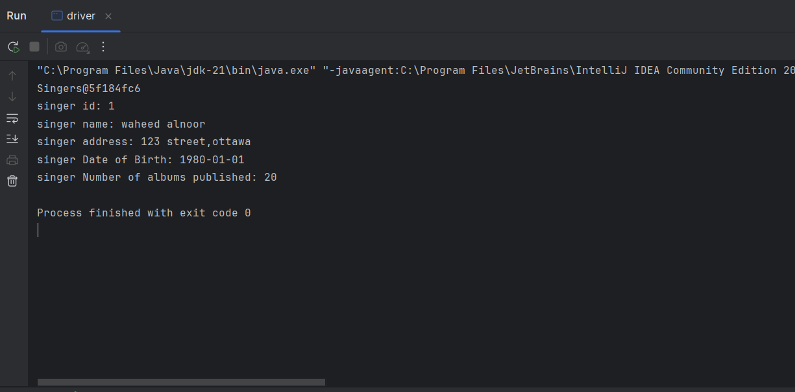

public class Singers {  
  
 private int id;  
 private String name;  
 private String address;  
 private String Dateofbirth;  
 private int Numofalbumspublished;  
  
 // constructor  
 public Singers() {  
 this.id = 0;  
 this.name = "default";  
 this.address = "default";  
 this.Dateofbirth = "default";  
 this.Numofalbumspublished = 0;  
 }  
  
 public Singers(int id, String name, String address, String Dateofbirth, int Numofalbumspublished) {  
 this.id = id;  
 this.name = name;  
 this.address = address;  
 this.Dateofbirth = Dateofbirth;  
 this.Numofalbumspublished = Numofalbumspublished;  
 }  
  
 // Setters  
 public void setid(int id) {  
 this.id = id;  
 }  
  
 public void setname(String name) {  
 this.name = name;  
 }  
  
 public void setaddress(String address) {  
 this.address = address;  
 }  
  
 public void setDateofbirth(String Dateofbirth) {  
 this.Dateofbirth = Dateofbirth;  
 }  
  
 public void setNumofalbumspublished(int Numofalbumspublished) {  
 this.Numofalbumspublished = Numofalbumspublished;  
 }  
  
 // getters  
 public int getid() {  
 return id;  
 }  
  
 public String getname() {  
 return name;  
 }  
  
 public String getaddress() {  
 return address;  
 }  
  
 public String getDateofbirth() {  
 return Dateofbirth;  
 }  
  
 public int getNumofalbumspublished() {  
 return Numofalbumspublished;  
 }  
}

public class driver {  
 public static void main(String[] args) {  
 //no argument constructor  
  
 Singers singer1 = new Singers();  
 // set the information of singer1  
 singer1.setid(1);  
 singer1.setname("waheed alnoor");  
 singer1.setaddress("123 street,ottawa");  
 singer1.setDateofbirth("1980-01-01");  
 singer1.setNumofalbumspublished(20);  
  
 System.*out*.println(singer1);  
 // get the information of singer1  
  
 System.*out*.println("singer id: " + singer1.getid());  
 System.*out*.println("singer name: " + singer1.getname());  
 System.*out*.println("singer address: " + singer1.getaddress());  
 System.*out*.println("singer Date of Birth: " + singer1.getDateofbirth());  
 System.*out*.println("singer Number of albums published: " + singer1.getNumofalbumspublished());  
 }